New Jersey State AFL-CIO
CODE-U
4/13 /22
Email to Affiliates:
School Board, Non-Partisan Municipal and Primary Elections
Important elections will take place all across our state in the next few months. We encourage all union members and family to be registered to vote and to fully participate in each. Election laws have changed and it has never been easier to register to vote or cast a ballot in New Jersey.
To register, an applicant can submit a paper application or complete the form online. To cast a ballot, a voter may choose to vote-by-mail, vote early at an Early Vote Center, or on Election Day at their traditional polling place. Voting takes place over 45 days ending at 8:00 pm on Election Day.
April School Board Elections: are taking place in about a dozen municipalities within Bergen, Essex, Hudson, Middlesex and Passaic counties.
April 19 Election Day
May Municipal Non-Partisan Elections are taking place in Belleville, Bayonne, Irvington, Ocean City, Paterson, Newark, and Long Branch.
April 19 Voter registration deadline
May 3 Vote-by-mail application deadline by-mail
May 6-8 Early vote
May 9 Vote-by-mail application deadline in-person
May 10 Election Day

June Primary Elections: Democratic and Republican primary elections are underway statewide.

April 23 Vote-by-mail balloting begins
May 17 Voter registration deadline
May 31 Vote-by-mail application deadline by-mail
June 3-5 Early voting
June 6 Vote-by-mail application deadline in-person
June 7 Primary Election Day

Visit www.njunionstrong.org to register to vote, download a vote-by-mail application, find your Early Vote Center or Election Day polling place. Please encourage all union members and family to be registered to vote and be ready to make their voice heard in these important elections.

Attached please find sample CODE-U messaging for the week of April 18, 2022. Your union brothers and sisters have the power to make this go viral. We encourage you, under your signature and union banner, to broadly share, send, text, tweet and post on your union’s social media pages through this planned and coordinated initiative. Please contact John Shea, COPE Director, at cope@njaflcio.org or 609-989-8730 with any questions.

In Unity,

Text & Tweet message:
Elections are coming up in May and June, are you ready to vote? Find out more about how and where to vote at www.njunionstrong.org, your union voter resource! However you decide, please make sure you and your family are registered and ready to vote.
Facebook Posts:
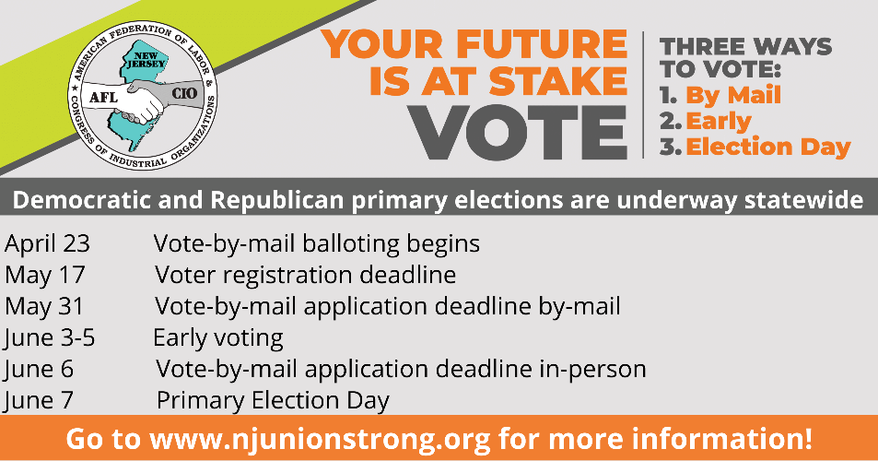

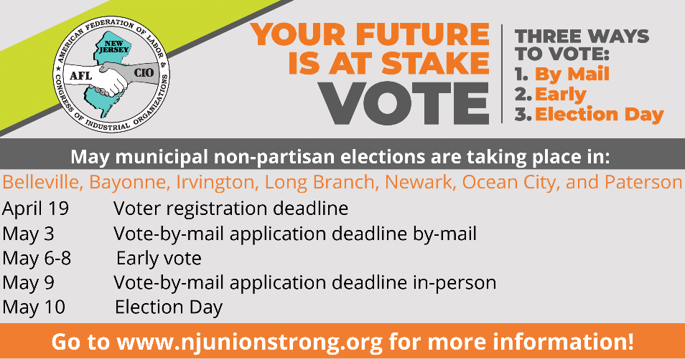

Caption: Elections are coming up in May and June, are you ready to vote? Find out more about how and where to vote at www.njunionstrong.org, your union voter resource! However you decide, please make sure you and your family are registered and ready to vote.

Website Post:
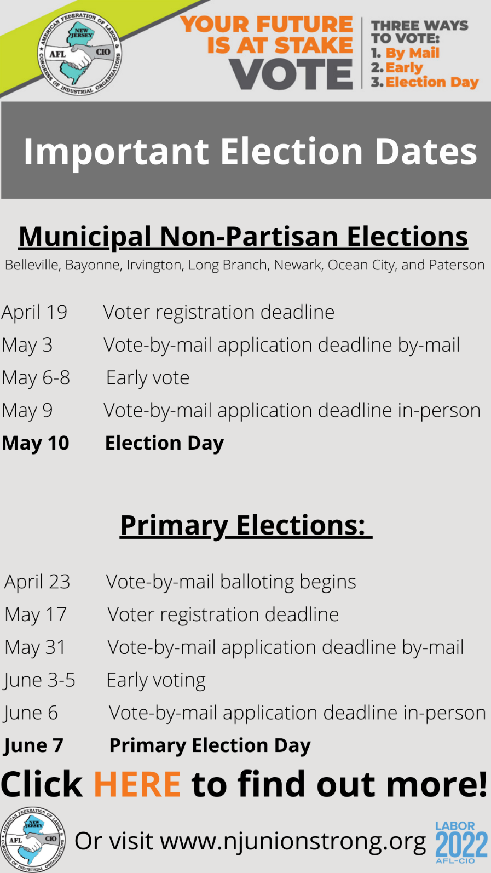

Caption: Elections are coming up in May and June, are you ready to vote? Find out more about how and where to vote at www.njunionstrong.org, your union voter resource! However you decide, please make sure you and your family are registered and ready to vote.
Image links to: www.njunionstrong.org

Blast email:
School Board, Non-Partisan Municipal and Primary Elections
Important elections will take place all across our state in the next few months. We encourage all union members and family to be registered to vote and to fully participate in each. Election laws have changed and it has never been easier to register to vote or cast a ballot in New Jersey.
To register an applicant can submit a paper application or complete the form online. To cast a ballot, a voter may choose to vote-by-mail, vote early at an Early Vote Center, or on Election Day at their traditional polling place. Voting takes place over 45 days ending at 8:00 pm on Election Day. Below is important election information and a link to election resources.
May Municipal Non-Partisan Elections are taking place in Belleville, Bayonne, Irvington, Ocean City, Paterson, Newark, and Long Branch.
April 19 Voter registration deadline
May 3 Vote-by-mail application deadline by-mail
May 6-8 Early vote
May 9 Vote-by-mail application deadline in-person
May 10 Election Day

June Primary Elections: Democratic and Republican primary elections are underway statewide.

April 23 Vote-by-mail balloting begins
May 17 Voter registration deadline
May 31 Vote-by-mail application deadline by-mail
June 3-5 Early voting
June 6 Vote-by-mail application deadline in-person
June 7 Primary Election Day

Visit www.njunionstrong.org to register to vote, download a vote-by-mail application, find your Early Vote Center or Election Day polling place. However you decide, please vote.

In Unity,

