CODE-U Messaging for Use 6/17/2022 and Afterward

Draft Email to All Affiliates

Endorsed Candidates are on the ballot!

Union members know best what other union members need. And what New Jersey and America need right now are more people fighting for them.

This year’s New Jersey State AFL-CIO Endorsed Candidates are the right choice for working families. With pro-labor stances on health and safety, an economy that works for all, jobs, education and skills training, civil rights and the right to join a union, these candidates for U.S. President, U.S. Senate and House, and county and local offices stand in solidarity with you.

Your union leadership and the Executive Board of the New Jersey State AFL-CIO chose these candidates because they share our union values.

Vote-by-Mail ballots are scheduled to be sent to New Jersey homes in a few weeks and voting will occur every day beginning September 24th and ending on November 8th. Additionally, Early Voting will occur from October 29th through November 6th. Election Day is now Election Season!

Know the Facts Before You Vote. Visit www.njunionstrong.org for more info.

Attached please find sample CODE-U messaging for the week of July 27, 2020. Please help it go viral. We encourage you, under your signature and union banner, to broadly share, send, text, tweet and post on your union’s social media pages through this planned and coordinated initiative. Please contact John Shea, COPE Director, at cope@njaflcio.org or 609-989-8730 with any questions.

The year’s elections are the most important our lifetime. Working together, the voice of working families will be heard on Election Day!

In Unity,
Charles Wowkanech Laurel Brennan
President Secretary-Treasurer

Draft Text & Tweet message:

NJ AFL-CIO: Our Endorsed Candidates share our values and will advocate for health and safety, an economy that works for all, and the right to form unions. Go to www.njunionstrong.org to know the Facts!
Draft Facebook & Website Post:
CAPTION: Our Endorsed Candidates share our values and will advocate for health and safety, an economy that works for all, and the right to form unions. Click below to find out more!
Image links to: https://njaflcio.org/know-the-facts/
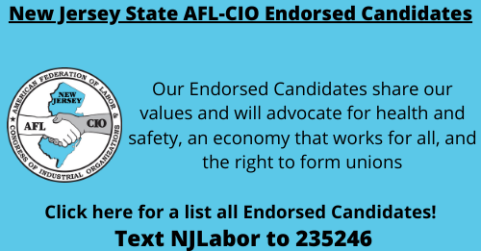

Post WsrfbFSBF\
Draft blast email:
Dear (first name):

Know the Facts!
The New Jersey State AFL-CIO’s Endorsed Candidates for 2022 are advocates for union families and all workers. They are the right choice for working families.
With pro-labor stances on health and safety, an economy that works for all, jobs, education and skills training, civil rights and the right to join a union, these candidates for House, county, and local offices stand in solidarity with you.
They believe in our Labor Movement and share our union values.
They deserve to represent you at every level of government.
Know the Facts Before You Vote. Vote for New Jersey State AFL-CIO Endorsed Candidates!

