To All Affiliates:

CODE U: Vote-by-Mail

Voting in New Jersey has begun! Ballots have been mailed out to voters with active vote-by-mail requests for the upcoming general election. If you received your ballot in the mail, don’t wait. Vote immediately for candidates who support working families and our union. Visit www.njunionstrong.org to learn more.

Any New Jersey voter can vote by mail. No reason or excuse needed. Vote-by-mail is safe, secure, convenient and easy. You can vote from the comforts of your home. You can vote any day and time you want with no lines at the polls or concern for weather. And you can track your ballot online to make sure your vote is counted!

To vote-by-mail, a registered voter must apply by November 1 by mail or November 7 in-person. All New Jersey registered voters are eligible.

Attached please find a sample CODE-U messaging for your use. We encourage you, under your signature and union banner, to broadly share, send, text, tweet and post on your union’s social media pages through this planned and coordinated initiative. Please contact John Shea, COPE Director, at cope@njaflcio.org or 609-989-8730 with any questions.

Working together, the voice of working families will be heard on Election Day!
In Unity,
Charles Wowkanech Laurel Brennan
President Secretary-Treasurer

Sample Text & Tweet message:
NJ Union Members: If you requested to vote-by-mail, be on the lookout for your ballot. To see the list of union endorsed candidates or to request a Vote-by-Mail ballot, go to www.njunionstrong.org.
Sample Facebook / Website Post:
Caption: If you requested to vote-by-mail, be on the lookout for your ballot. To see the list of union endorsed candidates or to request a Vote-by-Mail ballot, go to www.njunionstrong.org.
Image links to https://njaflcio.org/labor2022
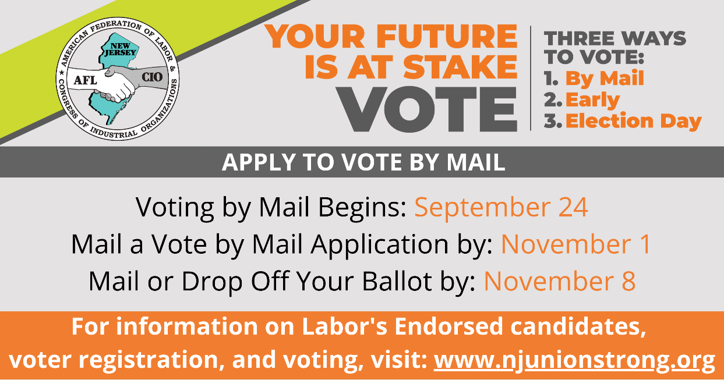

Sample Blast email:
Subject Line: Apply to Vote by Mail!

Voting in New Jersey has begun! When union members vote, we make sure our elected officials listen to the collective voices of New Jersey working families and put our priorities first.

If you would like to join the thousands of union members who are voting by mail, you must apply by November 1 by mail or by November 7 in person to receive your ballot in the mail. No reason or excuse is needed to vote by mail.

New Jersey union members should seriously consider voting by mail this fall. Here’s why: It’s safe, secure, convenient, easy, and there is a paper trail. You can vote any day and time you want with no lines at the polls or concern for weather. And you can track your ballot online to make sure your vote is counted!

You can download an application for a Vote-by-Mail ballot and see a wealth of other useful and vital information at www.njunionstrong.org.

Working together, the voice of working families will be heard on Election Day!

