September 2024

To: All Affiliates

**CODE U: Trump’s Project 2025 Agenda:**

**Workers’ Retirement Security is on the Ballot**

With the Project 2025 agenda threatening to enact disastrous policies for worker’s retirement security, it’s clear that workers can’t afford another Trump presidency. If elected to a second term, Trump would eliminate traditional Medicare, stop the federal government from negotiating drug prices, and would no longer penalize Big Pharma for raising drug prices more than the rate of inflation. Project 2025 would even allow cuts to healthcare coverage to seniors who need urgent healthcare, allowing states to eliminate or reduce Medicaid coverage for nursing home care.

Another policy that spells out disaster for working families would increase the age at which seniors become eligible to access Social Security retirement benefits without a financial penalty for retiring early. Causing drastic benefit cuts for a large majority of Americans, Trump would push [the full retirement age from 67 to 69](https://rollcall.com/2023/06/14/conservatives-budget-plan-renews-battle-over-seniors-benefits/).

These policies are just the tip of the iceberg. Project 2025’s 900-page document says, on page 710, that its proposals for social security could not be “[covered here in depth](https://static.project2025.org/2025_MandateForLeadership_CHAPTER-22.pdf).”

For more information on Project 2025, go to www.njunionstrong.org

To prevent these policies that would have a profound impact on retirees’ quality of life, we must urge all union members to vote. Voting begins on **September 21** when ballots will be mailed to voters on the permanent vote-by-mail rolls. Voter Registration deadline is **October 15**. A vote-by-mail application must be received by **October 29.**Early in-person voting will take place **October 26** through **November 3.** Election Day is Tuesday, **November 5.**To register, apply for a VBM ballot and more, visit www.njunionstrong.org.

Attached please find CODE-U messaging for your use. We ask you to text, tweet, post, and email and broadly distribute through your union’s social media pages. Please contact John Shea, COPE Director, at [cope@njaflcio.org](mailto:cope@njaflcio.org) or 609-989-8730 with any questions.

In Unity,

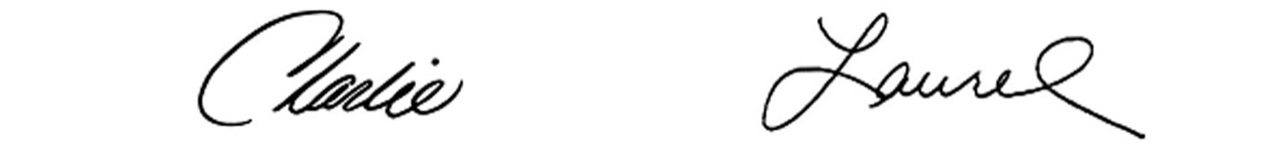

Charles Wowkanech Laurel Brennan

President Secretary-Treasurer

**Sample social media and text message:**

Trump’s Project 2025 agenda threatens our retirement security! Fight back! Register and vote!  
For more information, visit [www.njunionstrong.org](http://www.njunionstrong.org).

#StopProject2025

**Draft blast email:**

**Subject line:** Trump’s 2025 Agenda: Retirement Security is on the Ballot

With the Project 2025 agenda threatening to enact disastrous policies for worker’s retirement security, it’s clear that workers can’t afford another Trump presidency. If elected to a second term, Trump would eliminate traditional Medicare, stop the federal government from negotiating drug prices, and would no longer penalize Big Pharma for raising drug prices more than the rate of inflation. Project 2025 would even allow cuts to healthcare coverage to seniors and allow states to eliminate or reduce Medicaid coverage for nursing home care.

Another policy that Trump plans to implement would increase the age at which seniors become eligible to access Social Security retirement benefits without a financial penalty for retiring early. Causing drastic benefit cuts for a large majority of Americans, the Project 2025 agenda supports [pushing the full retirement age from 67 to 69](https://rollcall.com/2023/06/14/conservatives-budget-plan-renews-battle-over-seniors-benefits/).

For more information on Project 2025, go to www.njunionstrong.org.

To prevent these policies that would have a profound impact on retirees’ quality of life, we must urge all union members to vote. Voting begins on **September 21** when ballots will be mailed to voters on the permanent vote-by-mail rolls. Voter Registration deadline is **October 15**. A vote-by-mail application must be received by **October 29.**Early in-person voting will take place **October 26** through **November 3.** Election Day is Tuesday, **November 5.**To register, apply for a VBM ballot, and more, visit www.njunionstrong.org.