August 2024

To: All Affiliates

**CODE U: Trump’s Project 2025 Agenda:**

**The Rights of Building Trades Workers Are on the Ballot**

The Trump Project 2025 agenda would drastically change working conditions for workers in the building trades sector. Trump would repeal the requirements for federally funded projects to have project labor agreements (PLAs) and pay the prevailing wage in the region, leading to lower pay and more safety risks for workers. Trump has also previously stated publicly that he supports the repeal of the Davis-Bacon Act, the law which requires construction companies to pay the prevailing wage and have PLAs in effect.

To learn more about Project 2025 go to www.njunionstrong.org.

The Trump Project 2025 agenda also endangers workers by allowing small businesses to violate the Occupational Safety and Health Administration’s (OSHA’s) worker safety laws without punishment, no matter what deaths or injuries were caused by their negligence or recklessness.

Project 2025 clearly spells out disaster for all workers in the building trades sector. As labor leaders, we must clearly communicate how Project 2025 will negatively impact working families. To safeguard our democracy and union values, we must elect leaders who are willing to fight on behalf of working families.

It is important that union members vote early. Voting begins on **September 21** when ballots will be mailed to voters on the permanent vote-by-mail rolls. Voter Registration deadline is **October 15**. A vote-by-mail application must be received by **October 29.**Early in-person voting will take place **October 26** through **November 3.** Election Day is Tuesday, **November 5.**To register, apply for a VBM ballot, and more, visit www.njunionstrong.org.

Attached please find CODE-U messaging for your use. We ask you to text, tweet, post, and email and broadly distribute through your union’s social media pages. Please contact John Shea, COPE Director, at [cope@njaflcio.org](mailto:cope@njaflcio.org) or 609-989-8730 with any questions.

In Unity,

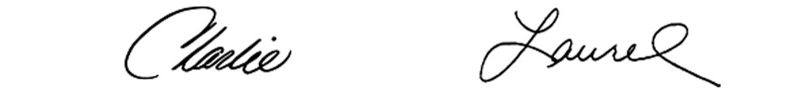

Charles Wowkanech Laurel Brennan

President Secretary-Treasurer

**Sample social media and text message:**

Trump’s Project 2025 agenda threatens to appeal the Davis Beacon Act and PLAs! Register and vote! For more information on Project 2025 go to [www.njunionstrong.org](http://www.njunionstrong.org).

#StopProject2025

**Draft blast email:**

**Subject line:** Trump’s 2025 Agenda: The Rights of Building Trades Workers Are on the Ballot.

The Trump Project 2025 Agenda would impact the working conditions for workers in the building trades sector by repealing the Davis-Bacon Act which requires construction companies to pay the prevailing wage in the region. Trump also threatens to repeal the Bipartisan Infrastructure Law, which provides funding to repair roads and bridges, and to invest in our public transportation system. Appealing this law will reduce the number of good-paying union jobs available.

Endangering workers, Project 2025 would allow small businesses to violate the Occupational Safety and Health Administration’s (OSHA’s) worker safety laws. Further impacting workers’ rights Project 2025 would allow corporations to get rid of a union even while workers are in the middle of a signed union contract.

Project 2025 clearly spells out disaster for all workers in the building trades sector. We must fight for our democracy and union values, by electing leaders who are willing to stand up for working families.

To learn more about Project 2025 go to www.njunionstrong.org.

Voting begins on **September 21** when ballots will be mailed to voters on the permanent vote-by-mail rolls. Voter Registration deadline is **October 15**. A vote-by-mail application must be received by **October 29.**Early in-person voting will take place **October 26** through **November 3.** Election Day is Tuesday, **November 5.**To register, apply for a VBM ballot, and more, visit [www.njunionstrong.org](http://www.njunionstrong.org).